ArrayList is a part of collection framework and is present in java.util package.
A Collection represents a single unit of objects, i.e., a group.
Collection in Java is a framework that provides an architecture to store and manipulate the group of objects.

Java Collections can achieve all the operations that you perform on a data such as searching, sorting, insertion, manipulation, and deletion.

Java Collection means a single unit of objects.

Differences between Array and ArrayList
- An array is basic functionality provided by Java. ArrayList is part of collection framework in Java.
- The Collection in Java is a framework that provides an architecture to store and manipulate the group of objects.
- //Java Collections can achieve all the operations that you perform on a data such as searching, sorting, insertion, manipulation, and deletion.
- //Java Collection means a single unit of objects.
- //Java Collection framework provides many interfaces
- //(Set, List, Queue, Deque) and
- //classes (ArrayList, Vector, LinkedList, PriorityQueue,
- //HashSet, LinkedHashSet, TreeSet).
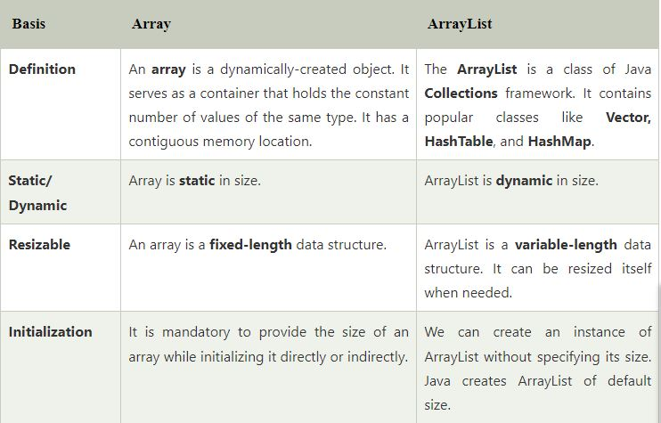
- Therefore array members are accessed using [], while ArrayList has a set of methods to access elements and modify them.

Two different ways to create an array.
- Array: Simple fixed sized arrays that we create in Java, like below
int arr[] = new int[10]
- ArrayList : Dynamic sized arrays in Java that implement List interface.
ArrayList<Type>Reference = new ArrayList<Type>();

Here Type is the type of elements in ArrayList to
be created

Why ArrayList is better than Array?
The limitation with array is that it has a fixed length so if it is full you cannot add any more elements to it, likewise if there are number of elements gets removed from it the memory consumption would be the same as it doesn’t shrink.
On the other ArrayList can dynamically grow and shrink after addition and removal of elements . Apart from these benefits ArrayList class enables us to use predefined methods of it which makes our task easy.
for (type var : array)
{
statements using var;
}

Iterator in Java is used to traverse each and every element in the collection. Using it, traverse, obtain each element or you can even remove. ListIterator extends Iterator to allow bidirectional traversal of a list, and the modification of elements.
Iterator in Java is used to traverse each and every element in the collection

ArrayList Methods

ArrayListClass.java

package pack1;

import java.util.*;

public class ArrayListClass
{

public static void display(ArrayList<Integer> temp)
{
for(Integer x:temp)
System.out.println(x);
}

public static void main(String[] args) {

ArrayList<Integer> obj = new ArrayList<Integer>( );

obj.add(10);
obj.add(20);
obj.add(30);
obj.add(40);
obj.add(50);

for(Integer x:obj)
System.out.println(x);

obj.set(1, 15);
obj.remove(3);

Iterator<Integer> iter = obj.listIterator();
while(iter.hasNext( ))
System.out.println(iter.next());

System.out.println("Display Method");
display(obj);

obj.clear( );
obj.add(10);
display(obj);
}

}

package arraylist;

import java.util.*;
public class ArrayListExample
{
public static void main(String args[])
{
//creating an instance of ArrayList
ArrayList<Float> list = new ArrayList<Float>(1);
//adding element to arraylist
list.add(12.4f);
list.add(34.6f);
list.add(56.8f);
list.add(78.9f);
//iteration over ArrayList using for-each loop
for(Float f:list)
{
System.out.println(f);
}
}
}

Second Method :
package arraylist;

import java.util.*;
public class ArrayListExample
{
public static void main(String args[])
{
//creating an instance of ArrayList
ArrayList<Float> list = new ArrayList<Float>(1);
//adding element to arraylist
list.add(12.4f);
list.add(34.6f);
list.add(56.8f);
list.add(78.9f);
//iteration over ArrayList using for-each loop

Iterator<Float> iter = list.iterator();
while(iter.hasNext( ))
System.out.println(iter.next());
}

}

